Home Page

The home page is the first thing that the user sees, and so the design of it is important. The wireframes that we had previously designed gave us an overview of what we had to do.

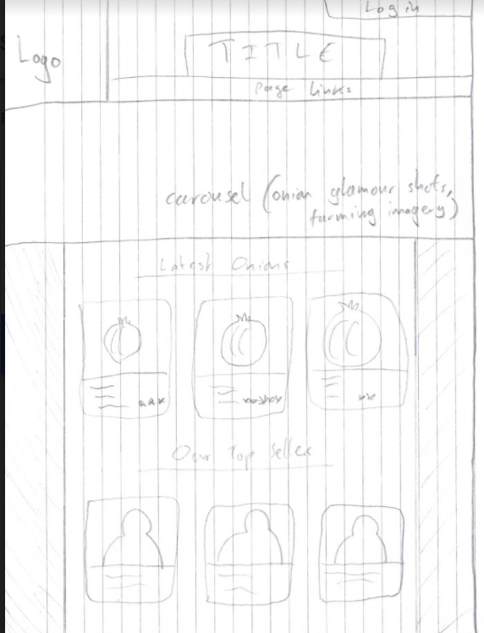

Step one was to create the image carousel. We decided early on that we liked the design of notonthehighstreet.com, and so turned to it for inspiration.

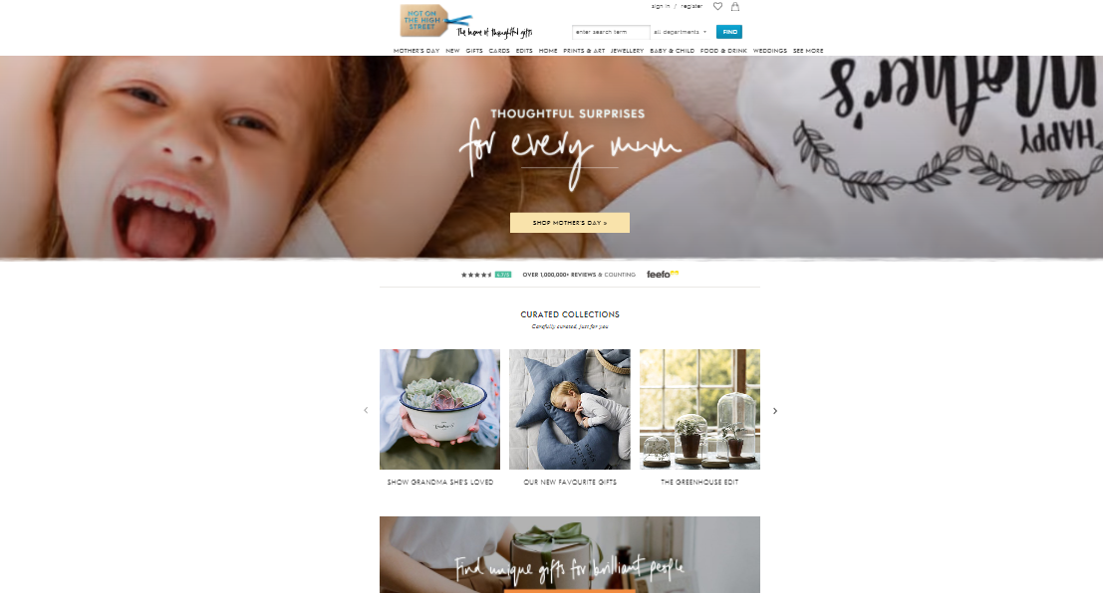

The site that we used for inspiration uses a carousel that shows multiple images to the user. The image changes after a few seconds, which we thought was an effective way of updating the look of the home page and keeping users engaged without breaking the consistency in layout and other such things. We implemented a similar thing into our website but adapted it, a less humble individual would say ‘improved it’, to fit our theme of onions.

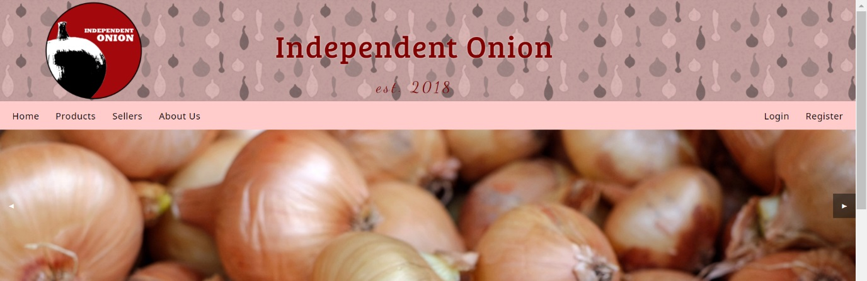

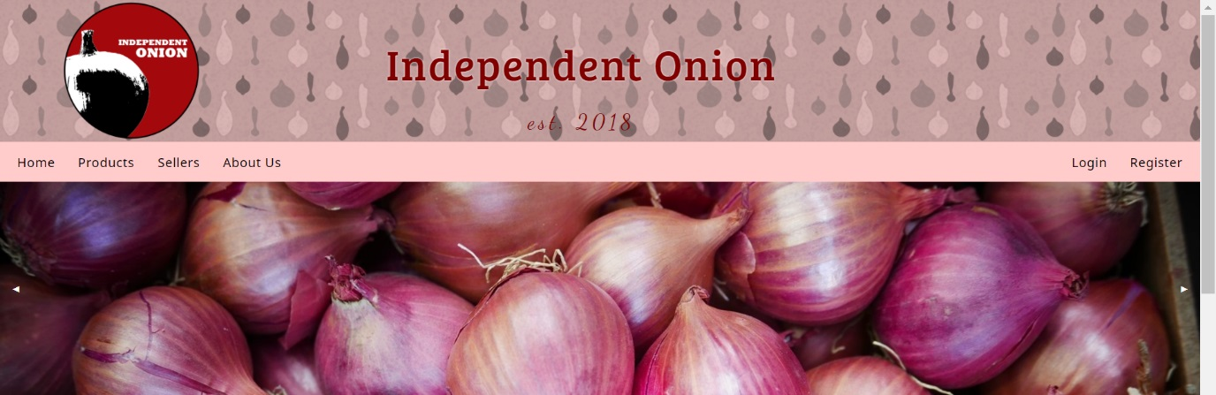

Our carousel allows users to change the image themselves via arrows on the left and right of the slider. We felt that this feature was lacking from our inspiration.

We needed additional content on our home page, a simple omnipresent banner and slideshow of images would not suffice.

We referred to the wireframes that we designed earlier; links to the most recently added products and sellers should be present on the home page.

This next screenshot is zoomed out to show the issue we faced- excess of products:

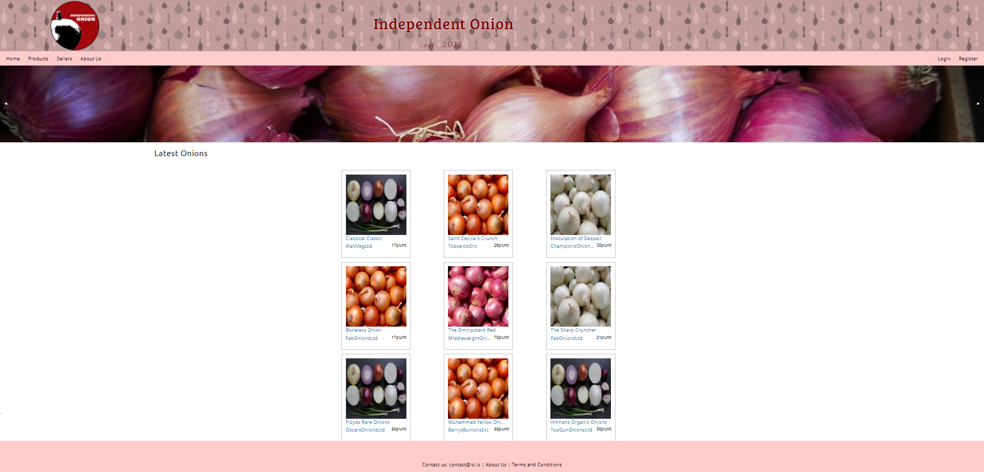

This was fixed with a modification of the query that called the products from the database. Rather than displaying all products, the definitive version displayed only three. A similar thing was done with sellers, displaying the three highest rated sellers.

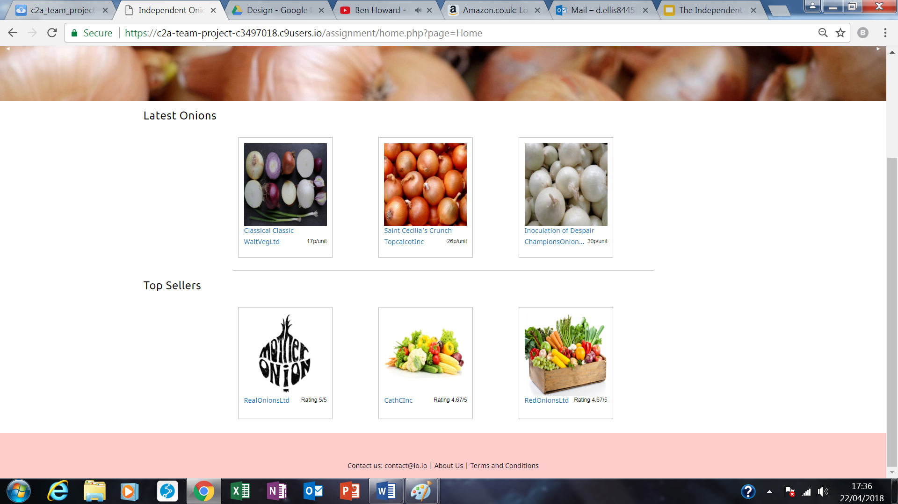

We were proud of this as we recreated the wireframe design perfectly.